AP Gov & Poli
Argument Essay

General Argumentative Elements
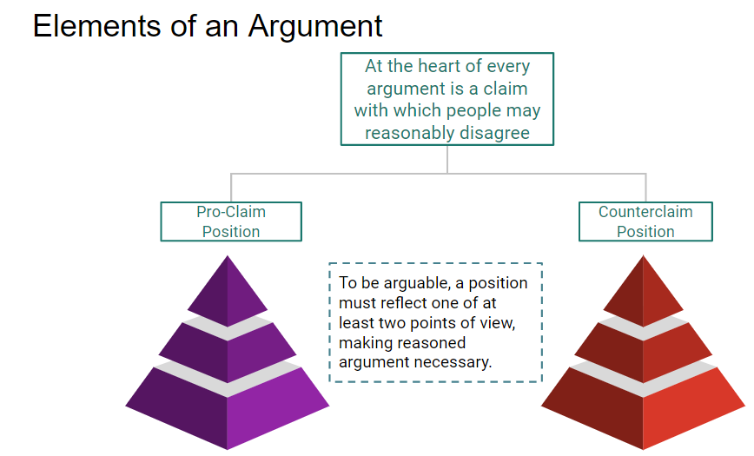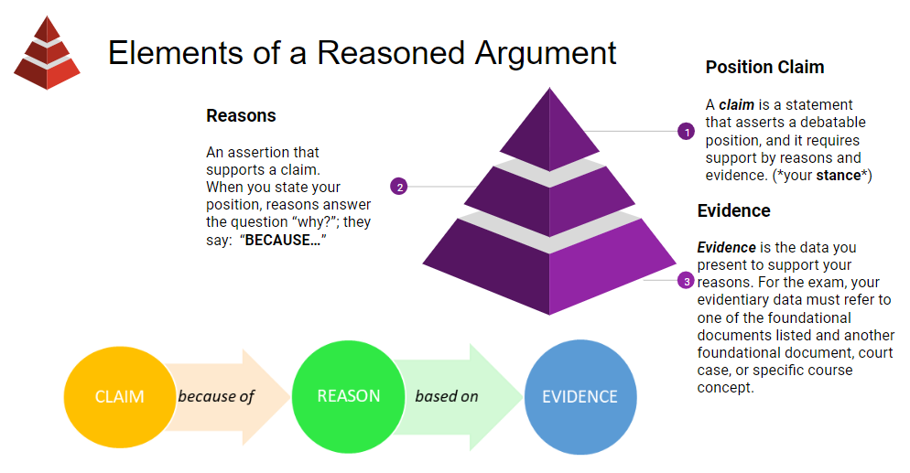

In your AP Gov Argument Essay
Thesis statement with line of reasoning
- Take a stand… Restate the prompt question as declarative statement that asserts a clear position. The prompt question will designate opposing viewpoints on an issue, and your thesis turns the question into a position by asserting one of those viewpoints.
- Because… Briefly summarize the evidence you will focus on to support your viewpoint
- And/Such that/Therefore… So what? Connect your evidentiary focus back to the core significance of the governmental or political issue in the prompt.

Sample Prompts
Prompt #1 (Presidential Campaign Length)
Respond to all parts of the question. In your response, use substantive examples where appropriate.
In the early days of the country, presidential campaigns were conducted within a significantly shorter period of time. Today, it is common for potential presidential candidates to start campaigning shortly after the congressional midterms end, making the presidential campaign season a regular fixture in American political life.
Develop an argument that explores whether longer presidential campaign seasons are helpful or harmful to American democracy.
Use at least one piece of evidence from one of the following foundational documents:
o The Federalist 70
o Brutus 1
o Article II of the United States Constitution

Prompt #2 (Federal Government Power)
The United States Constitution establishes a federal system of government. Under federalism, policymaking is shared between national and state governments. Over time, the powers of the national government have increased relative to those of the state governments.
Develop an argument about whether the expanded powers of the national government benefit or hinder policymaking.
Use at least one piece of evidence from one of the following foundational documents:
o The Articles of Confederation
o Brutus 1
o The Federalist 10

Prompt #3 (Judicial Term Limits)
The Constitution provides that judges shall hold their offices during good behavior for lifetime terms.
Take a position on whether judges should have lifetime or fixed terms.
Use at least one piece of evidence from one of the following foundational documents:
§ Articles of Confederation
§ The Federalist 51
§ Tenth Amendment

Transitional language to show REASONING

Build on the preceding item/idea
Addition (of info or emphasis): also, and, in fact, indeed, moreover, in addition, furthermore, besides X, both X and Y, above all, more/most importantly
Example: such as, for instance, in particular, notably, consider, specifically, for example, as an illustration
Clarification: actually, in other words, by extension, ultimately, in short, that is (to say), namely, more precisely, to put it another way
Similarity: similarly, in like manner, likewise, equally, in the same way, by the same token
Reference: regarding, considering, the fact that, as for, on the subject of

Contrast or challenge the preceding item/idea
Contrast: but, however, though, equally, by way of contrast, while, on the other hand, (and) yet, whereas, in contrast, (when) in fact, conversely, despite, while, nonetheless
Concession: admittedly, granted, of course, although (it is true), notwithstanding, even so, on the other hand
Dismissal: regardless, whatever the case, all the same
Counterclaims: Some will argue, a number of __ suggest, some believe/feel that, while it may be true that

Make a causal connection
Causation/consequence: accordingly, as a result, consequently, thus, hence, therefore, since, because, for this reason, as a result
Condition: (even) if, (only) when, on the condition that, in the case that, provided that, in the event, unless, given that, inasmuch as, insofar as, otherwise, if so

Indicate ordering
Sequence: first, second, third..., to begin, at first, initially, first of all, subsequently, previously, after, before, next, then, eventually, at last, finally, lastly, to conclude, as a final point
Retrospection: to return to, to resume, as previously stated/mentioned, overall, in summary, briefly, given these points, as has been noted, in sum, altogether, to summarize

Advanced Rhetorical Argumentation Structures

Nestorian Order:
Second strongest point + examples, minor points + examples
Opposing theory/point + examples
Refute opposition by arguing counter points + examples
Strongest, best point + examples

Rogerian argument (do NOT use for AP Gov Essay, though…):
Introduce issue fairly and neutrally
Explain opposing views fairly + supporting examples
State your proposition/position; give strong reasons + compelling supporting examples
State your position’s advantages or offer a logical compromise

